Best in Show 2010
Kenny Dickerson, Eco-Master Builders
(760) 899-0700

We have assembled distribution, dealership, and re-sell relationships with each of the following “Green Built” products; we call these products “Best in Show” for each category they represent. For a free consultation on how to become more energy efficient call Kenny Dickerson.
- ReddiForm (ICF Foam Blocks)
ReddiForm's insulating concrete form (ICF) building technology has served commercial and residential builders, local and state government and energy-conscious home owners since 1990. Our permanent buildings, reinforced concrete walls and foundations offer structural, energy-saving and cost-saving advantages over traditional stick-frame construction and standard insulation methods. ICF construction provides for more efficient construction, structural stability and a healthier living environment while reducing energy consumption.
- 30% lower construction cost, 50% less construction time
- Multi-dimensional building product
- Better moisture & mold control
- Greater wind sheer and seismic stability

- GreenSwitch (X-10, Zigby Technology Plugs & Switches)

Difference
A switch to GreenSwitch is easy. GreenSwitch can be retrofitted into existing electrical systems and, in the average household, can be installed in about an hour. The savings are immediate. GreenSwitch saves you money and reduces your carbon footprint at the same time, giving you the opportunity to make a difference for your family and in the world. All this with the slide of one convenient switch!

Put an End to Phantom Electricity Use with One Switch
- Professional installation can be done in approximately one hour
- The system's wireless technology does not interfere with other wireless devices
- Use of GreenSwitch significantly extends the life of heat/air conditioning systems, televisions, and lighting fixtures

- Power-Save (Power Factor Optimizing Capacitors)
SAVE UP TO 25% ON YOUR COMMERCIAL/INDUSTRIAL ELECTRIC BILLS!  The Power-Save 3400 & Power-Save 3200 Reduce the Amount of Inductive Load in Commercial and Industrial Environments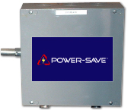 | The Many Benefits of the Power-Save 3400 & Power-Save 3200 Include:  --> Lowers electric bills up to 25%!  --> Reduces electricity required by inductive loads (motors)!  --> Enhances capacity of existing electrical system!  --> Eliminates harmful power surges!  --> Protects appliances and sensitive electronic equipment!  --> Reduces harmful effects caused by electrical noise!  --> Power Factor Optimization!

- Coolorado (Evaporative Cooling units)
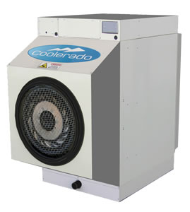

Coolerado M30, M50, M60
Cooling capacity increases as temperature increases. No chemical refrigerants. Easy maintenance. Low water use. No moisture added to conditioned air. New, patented thermodynamic cycle. With zero side clearance, the M30 can be placed in multiple unit configurations.

All Coolerado air conditioners have these features
- 100% fresh, filtered, cool, and comfortable air with no added humidity
- Uses up to 90% less electricity than traditional air conditioners
- EER of 40 plus
- Cooling capacity increases as temperature increases
- Natural, no CFC refrigerants
- 5-year limited warranty
- Low, easy maintenance
- Affordable, cost competitive with traditional A/C
- Quiet
- Net zero water impact
- Patented, new thermodynamic cycle and technology
- Solaranda (Solar Veranda Kits)
The SOLARANDA is EnergyPro's own, exclusive product. It is the best way to integrate solar into beautiful outdoor architecture. This innovative veranda structure will make a beautiful centerpiece in your garden and for your outdoor entertainment!
Offers a beautiful, decorative, focal point in a yard as well as much needed shade AND electricity for your home!
Solar power is a hedge against rising utility costs! Fix your electricity costs now with great rebates and tax incentives in your area.
The supporting structure for the Solaranda™ can also be included in your federal tax credit! So consider incorporating a unique and beautiful addition to your landscape with a Solaranda™ that is attached to your home (veranda, patio cover or balcony) or create a shady spot in another part of your yard or over a deck with a free-standing structure as an architectural element.
Solaranda™ Advantages:
- Provides much needed shade
- Eliminates roof structural analysis needed in some cities
- No roof installation - means no potential leaks or issues with roof integrity
- Patio Structure is included in tax credit
- No maintenance with Aluminum patio shade structure
- Can be tilted to reduce maintenance or increase rebate
- Can achieve desired southern orientation when regular roof-line of home cannot

Our SOLARANDA™ will qualify for a 30% Solar Federal Tax Credit, State Incentives and Utility Company Rebates!

- Verve (Living Lighting Systems)
- What happens if you have a five year old, and she can't reach the light switch in her room?
- What happens if your elderly mother moves in with you, and it's hard for her to get out of bed to turn off the lights?
- What happens if you want to rearrange the furniture in your study, but the light switch is in the way?
- There are two answers to questions like these:
- If you have conventional light switches in your home, the answer is, "Sorry, you're out of luck."
- On the other hand, if you have Verve Living Systems, the answer is, "Grab the switch and move it." Really, it’s that easy.
- Unlike conventional switches, which are hard-wired, our switches are wireless and completely movable. You can put them anywhere you like and move them instantly.
- That’s what advanced technology can do for you.
Verve Living Systems is a new brand within Masco Corporation, a leading manufacturer of consumer products for the home improvement and new home construction markets.
Verve was founded by a small team of Masco executives who discovered a technology and recognized the potential it had for dramatically improving the way consumers live their lives and the way developers, homebuilders, architects, electricians and other tradespeople design and build houses.
Developed by EnOcean GmbH, a spin-off of Siemens Corporation, this patented technology is a remarkable breakthrough in energy-harvesting, radio frequency science. EnOcean engineers discovered a way to gather energy from the simple act of clicking a switch – energy that can be used to transmit a small, compact radio signal wirelessly and at astonishing speed.
What we saw in the technology was the opportunity to support a wide range of wireless, battery-less applications for the home that were at once remarkably innovative, enormously energy efficient and surprisingly affordable.
The company's first application is a whole house lighting control system that gives homeowners a new level of control over the lights in their home. Additional applications will become available in the near future. In the works are applications in HVAC monitoring and control, whole house environmental monitoring and home security.

- WindBuster (Electric Generating Wind Turbines)
A small helical wind turbine for use on sites with changeable wind direction. No need to re-orientate the WindBuster, the helical blades collect the maximum power from all wind directions and are very quiet compared to traditionally designed wind turbines. We offer one-size (6m high, 3.25m diameter) helical blade with various mast heights. The WindBuster can be a stand-alone unit or part of a small wind farm. Easily connected to your electrical system, a WindBuster should provide 100% of a four bedroom family home’s electrical needs in a good wind location.

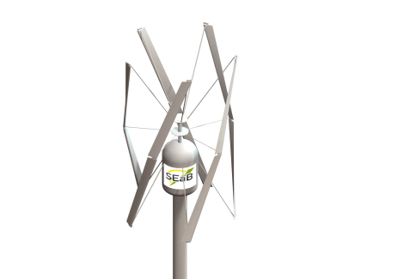

- GeoPower (House Systems)
It's only natural...
...that in a world that is compelling us to simplify our lifestyles, and necessitating that builders conform to more stringent environmental standards, innovative solutions to ecological challenges are born within a tradition that places high value on the simple and pure, the natural and healthful.

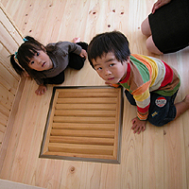 |  | Geo Power System's highly acclaimed and award-winning technology, has steadily and justifiably won for itself an impressive place in Japan's green building industry-with it's geothermal energy solutions the preferred choice in more than 70% of all officially recognized green buildings in Japan.

Not just green......pristine!
- Geo Power System: The geothermal HVA solution that...
- Moderates temperature differences up to 30 degrees F
- Lowers heating and cooling bills
- Purifies indoor air, removing 95% of dust and 99% of pollen
- Includes automatic air circulation and ventilation
- Naturally controls humidity
- Operates in an entirely chemical-free environment
- Reduces CO2 emissions

